

SETTING UP A WEB SERVER WITH APACHE

OMIS 660





**LAB SUMMARY**:

With the help of this lab we get to know how a web server is created.web server is simply used to exchange data with the world wide web with the help of http,here we use apache to create a web server.Apache is a http web server which is free and also open resource software,apache is used here to create a web server and we will configure the web server depending on our needs.Configuration of firewall to allow the web server and also to configure our own domain and additional domains will also be learned with in this lab.we also get to know how to test server locally and remotely.

**LAB OBJECTIVES**:

1)To know how a web server works.

2)Perform some basic configurations on the apache web server.

3)To configure the firewall depending on the server.

4)To get to know how to test the server locally and remotely.

5)To make changes to the DNS server for your network.

6)To host webpages for domains.

7)To confire the web server for it to respond to the compony requests.

**PROCESS**:

STEP 1: Installation of webserver from the following link <https://www.apachelounge.com/> and choosing the bit 64 or 32.

STEP 2: Checking for the "Microsoft Visual C++ 2015 Redistributable" (or later version) on system or else downloading from the following link <https://www.microsoft.com/en-us/download/details.aspx?id=48145>.

STEP 3: The zip file httpd-2.4.18-win64-VC14.zip is extracted and is placed in the directory “C:/Program Files/Apache24”.

STEP 4: Now to configure the webserver we have to do some changes in “*httpd.conf”*  file which is present “conf” folder in “Apache 24”.

ServerRoot :

ServerRoot "C:/Program Files/Apache24"

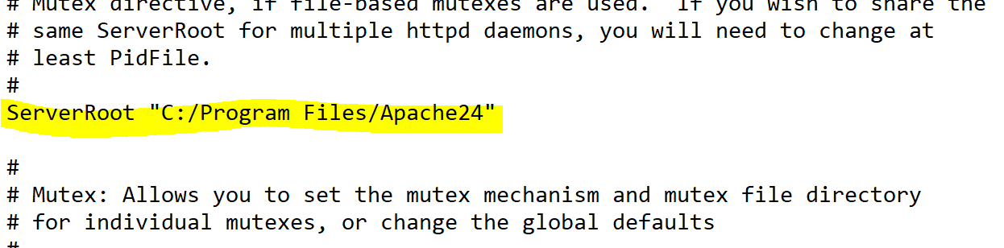

ServerName:

ServerName localhost:80

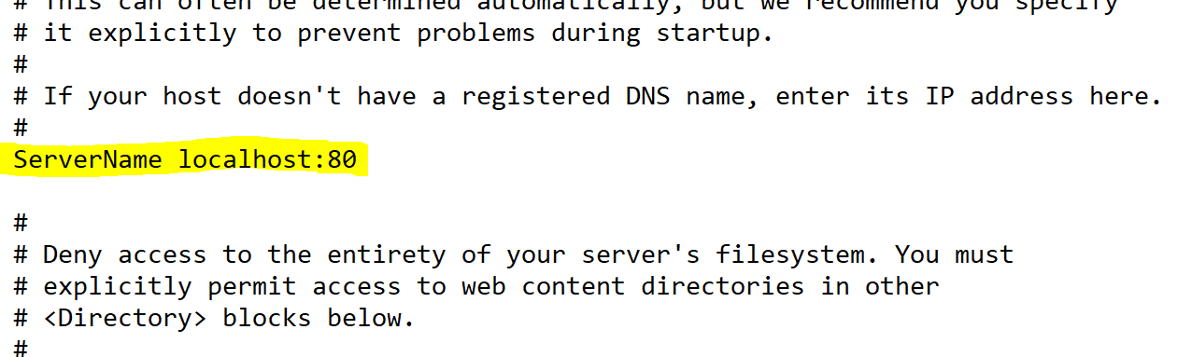

DocumentRoot:

DocumentRoot "C:/Program Files/Apache24/htdocs"

<Directory "C:/Program Files/Apache24/htdocs">

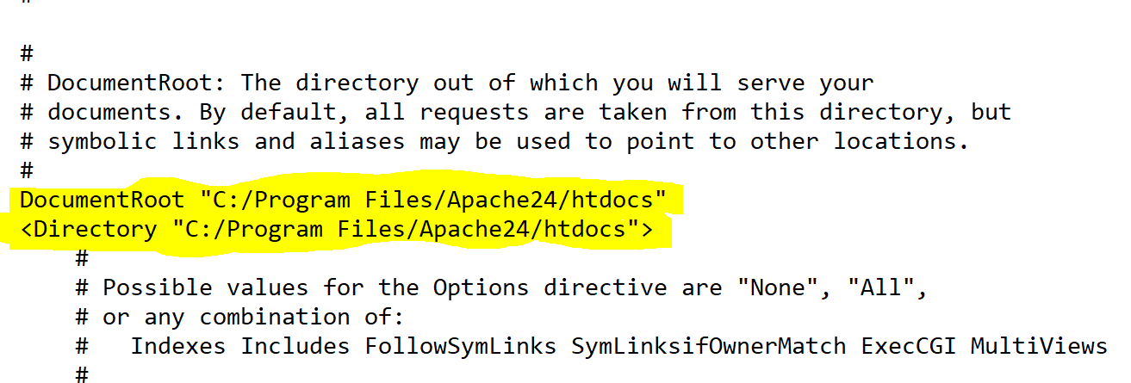

DirectoryIndex:

DirectoryIndex index.php index.html

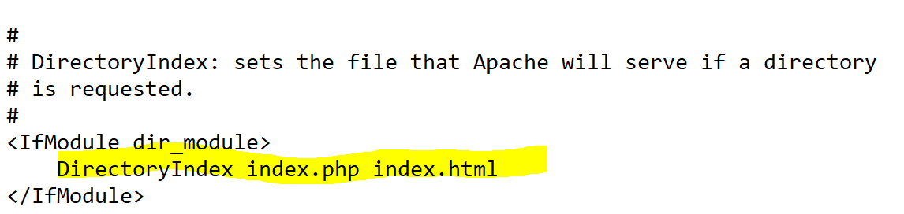

STEP 5:Now navigating to the directory “C:/Windows/System32/drivers/etc”

Opening the file in a text editor and adding “127.0.0.1 localhost” in the first line.

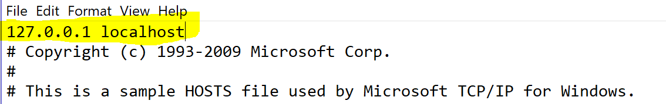

STEP 6: Now the webserver is configured and it will be functioning and start it by operating the following file “C:/Program Files/Apache24/bin/httpd.exe”.

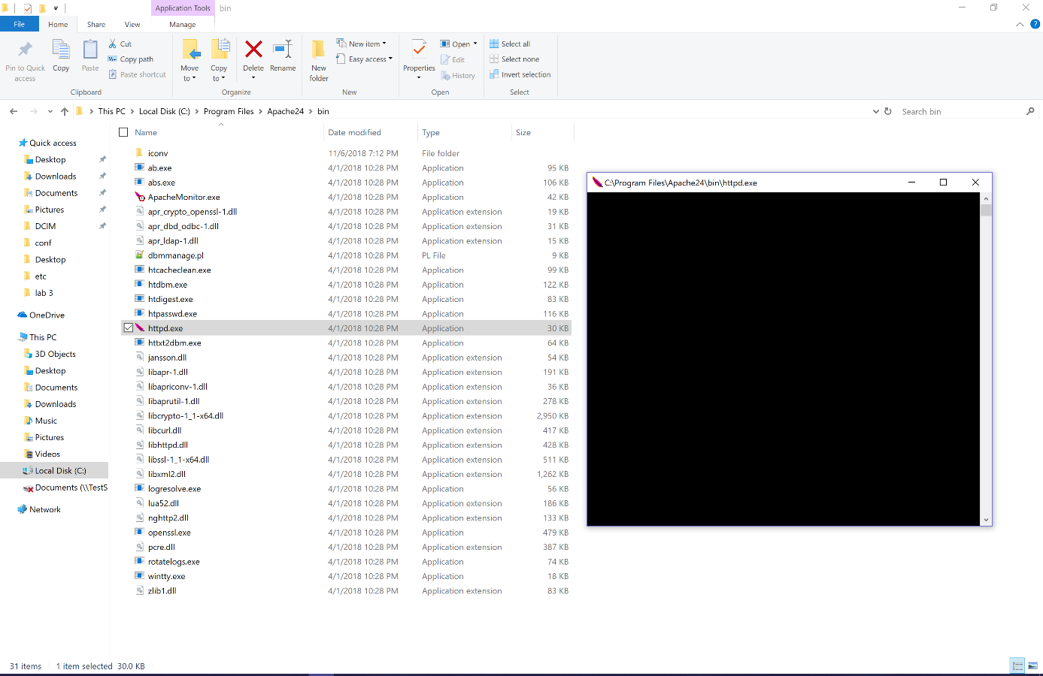

STEP 7: Now going to web browser type the link :<http://localhost/> and it will display as.

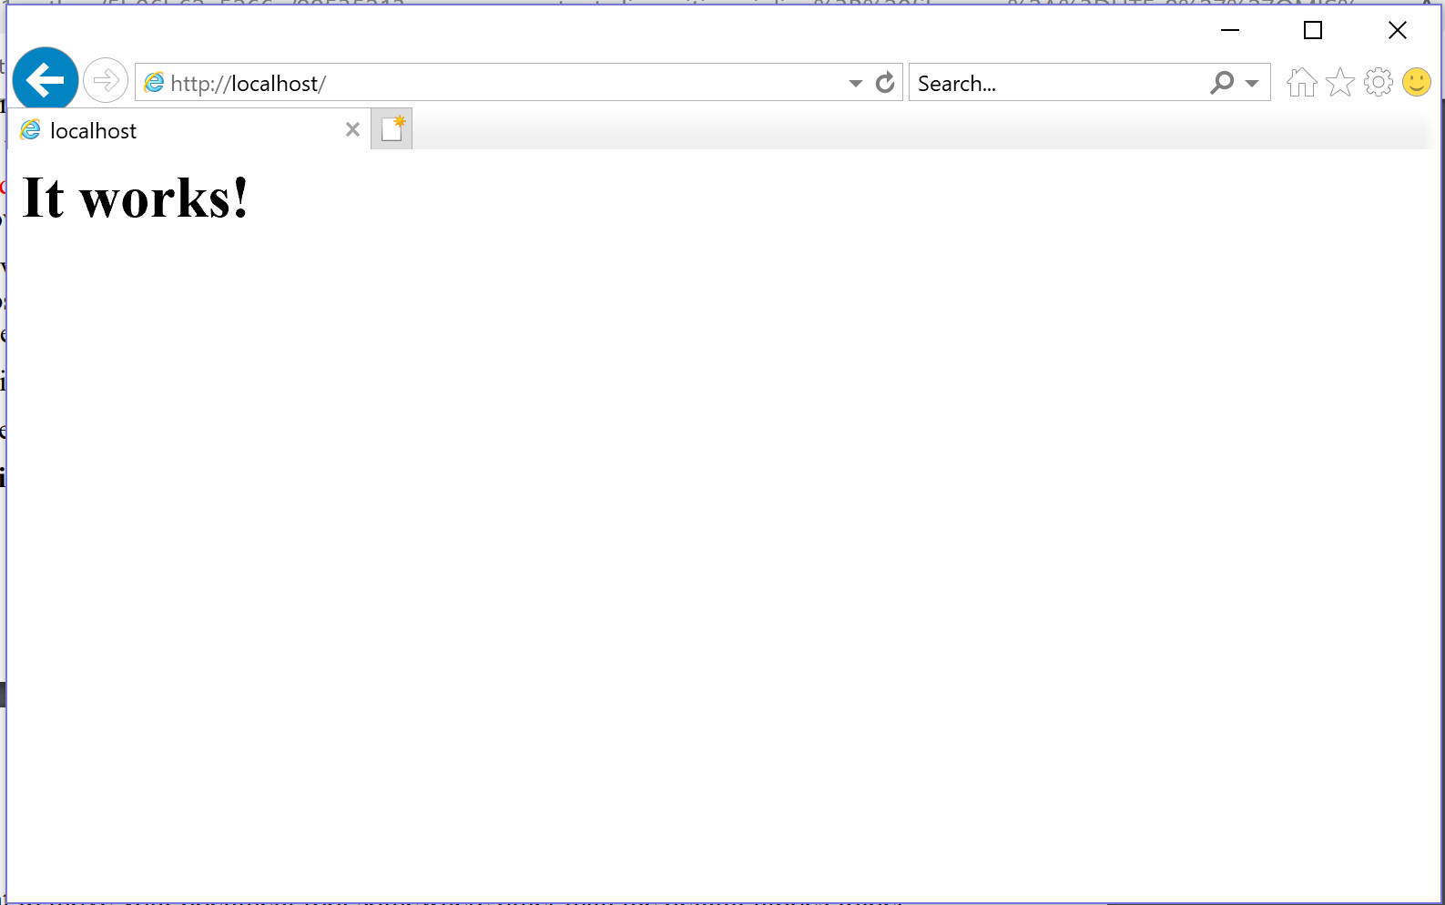

STEP 8: Adding the following directory “C:/wwwroot”

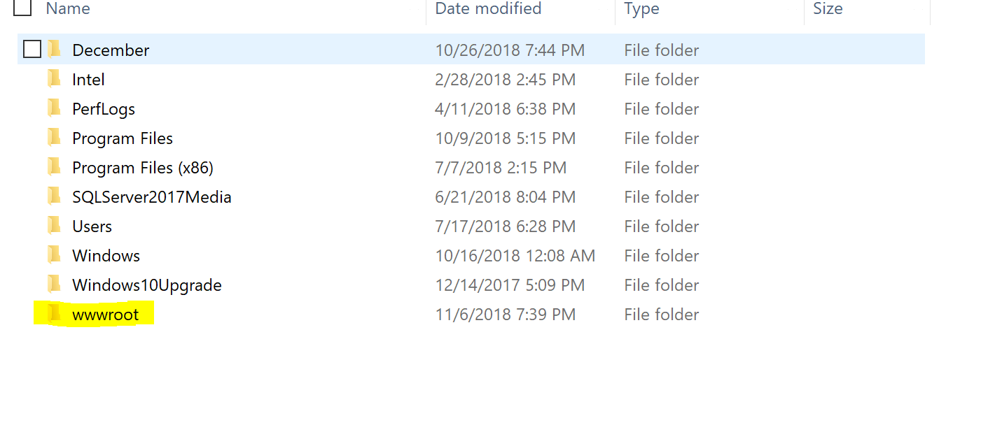

STEP 9: To permit the Apache web server to communicate through the Windows Firewall, you will need to go to the Windows Control Panel. Click on “System and Security” followed by Windows Firewall.

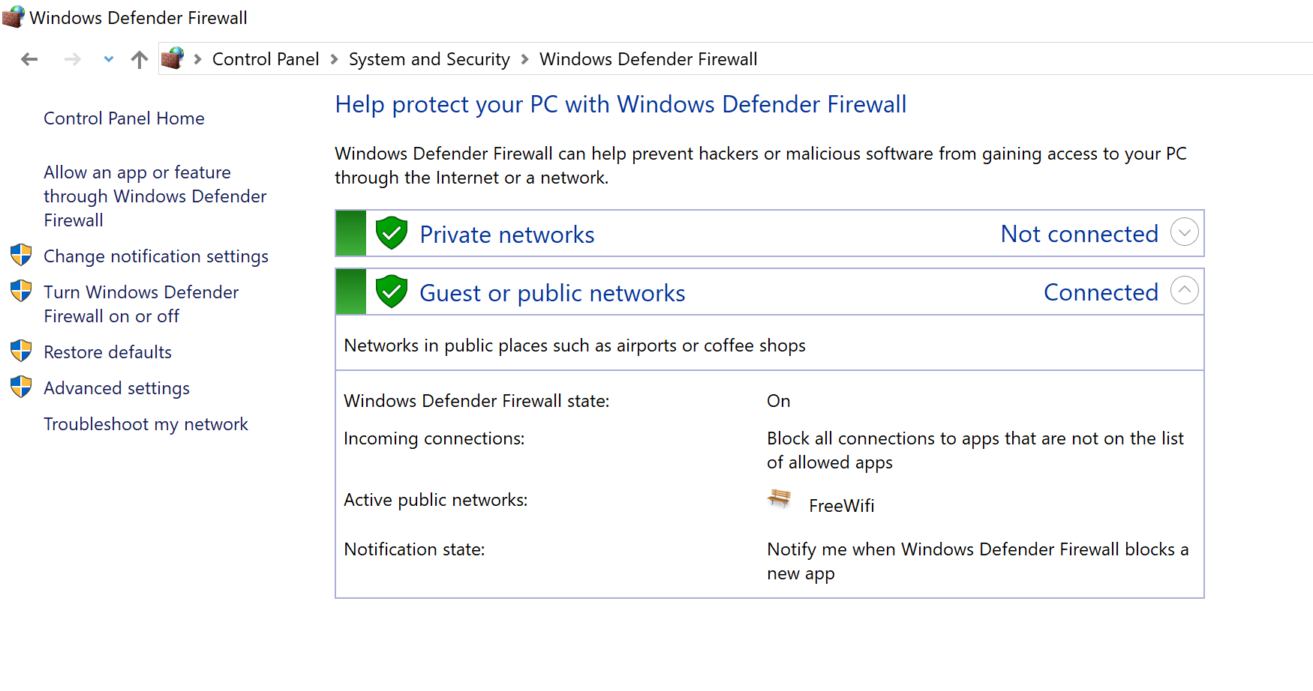

STEP 10: Click on “Allow an app of feature through windows firewall defender” and click on “change setting” and click on “Allow another app”.

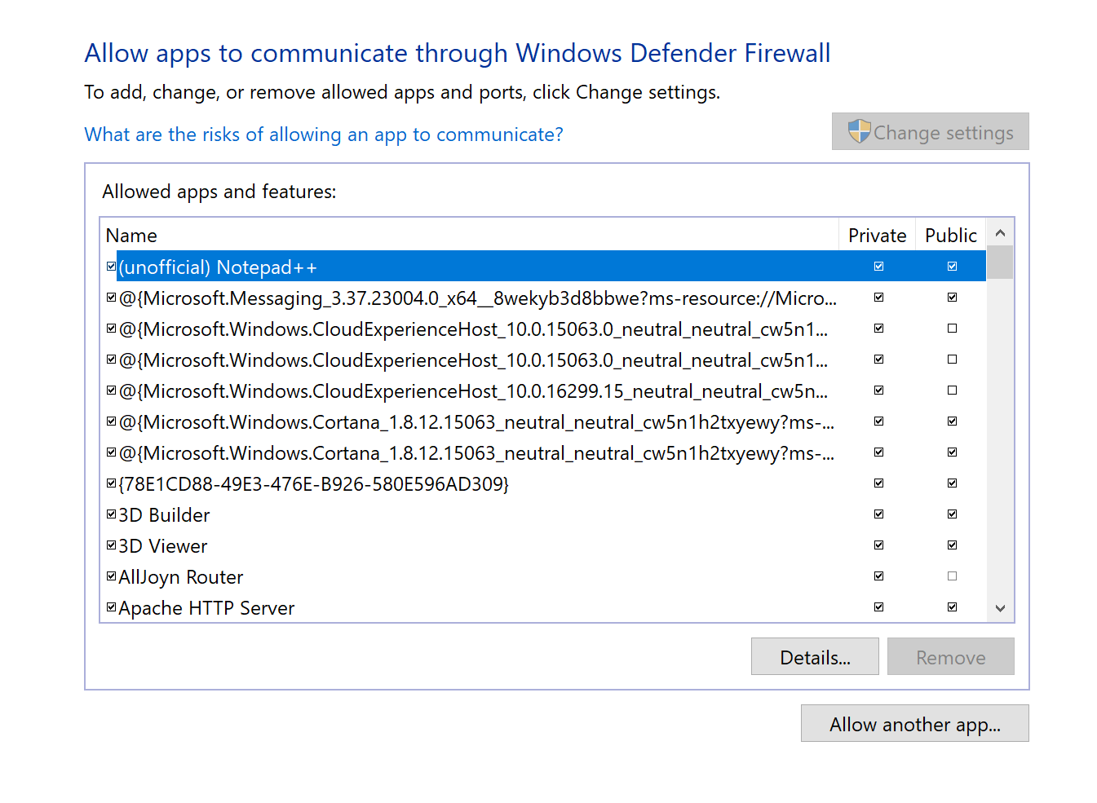

STEP 11: You will get into a new window where you can find “Browse” click on it and you will get a window and select “httpd.exe” file and click on open and click on add.

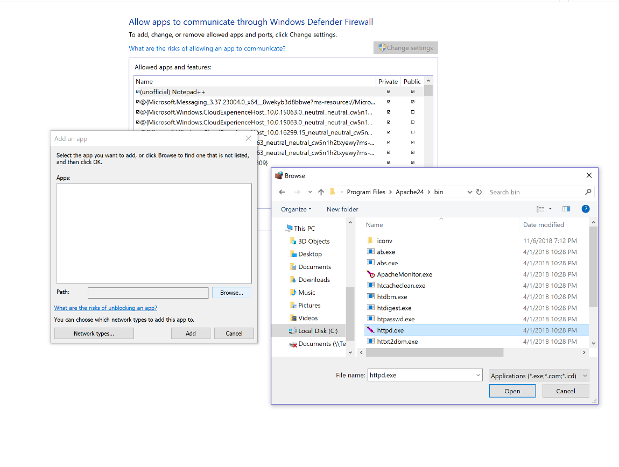

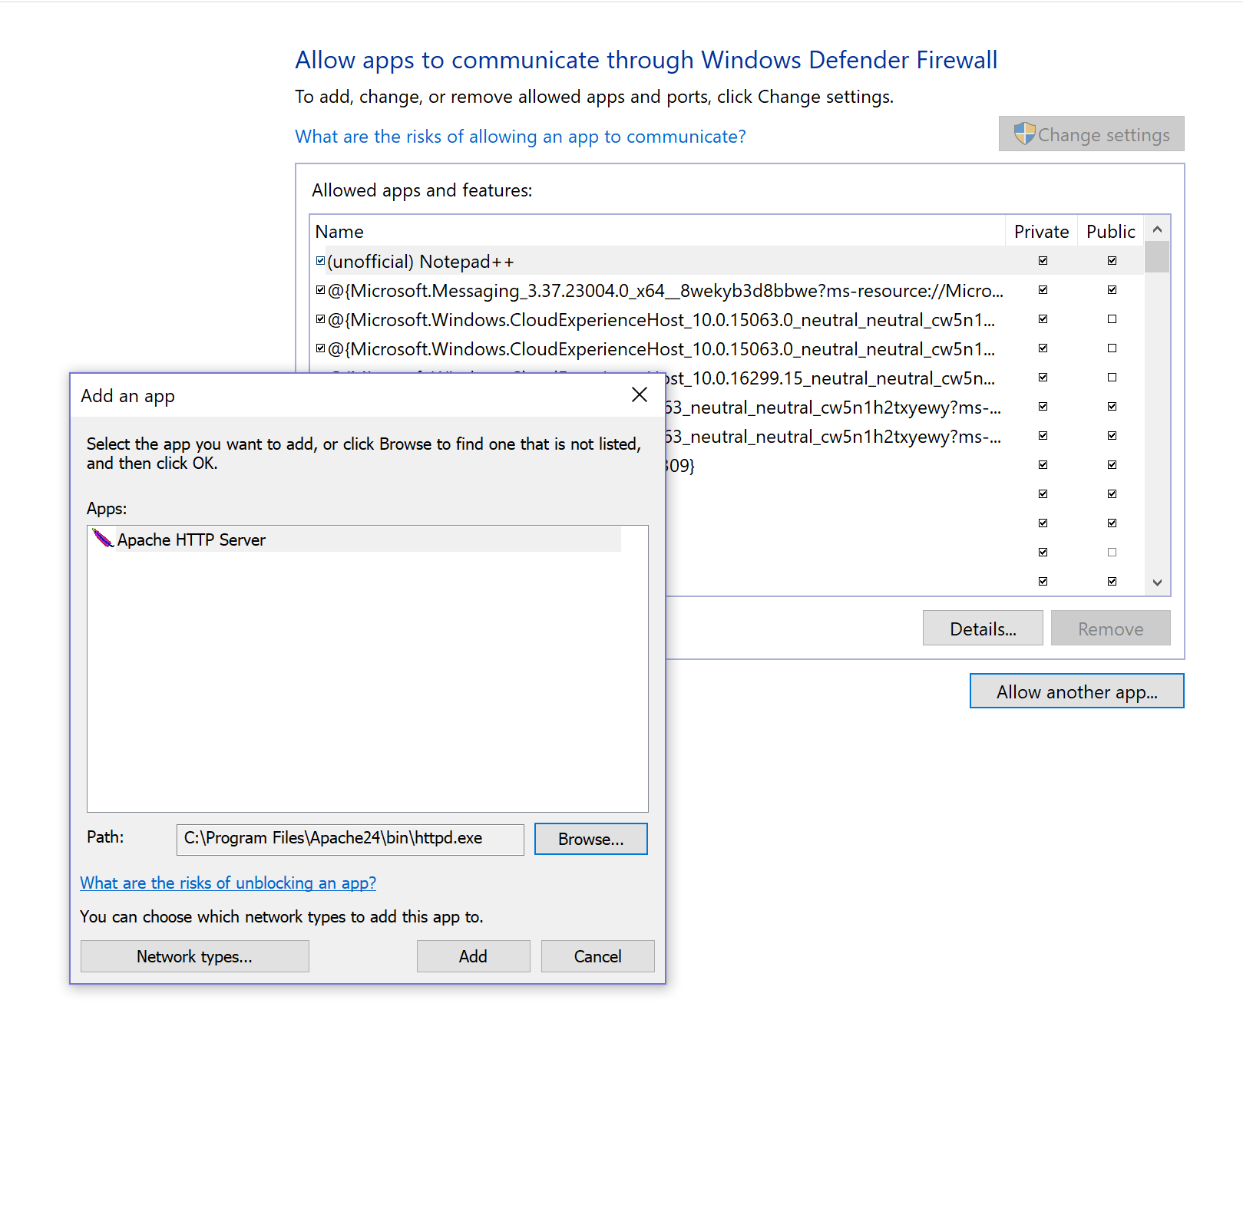  
STEP 12: Check the Apache HTTP Server and the check boxes of private and public should be enabled.

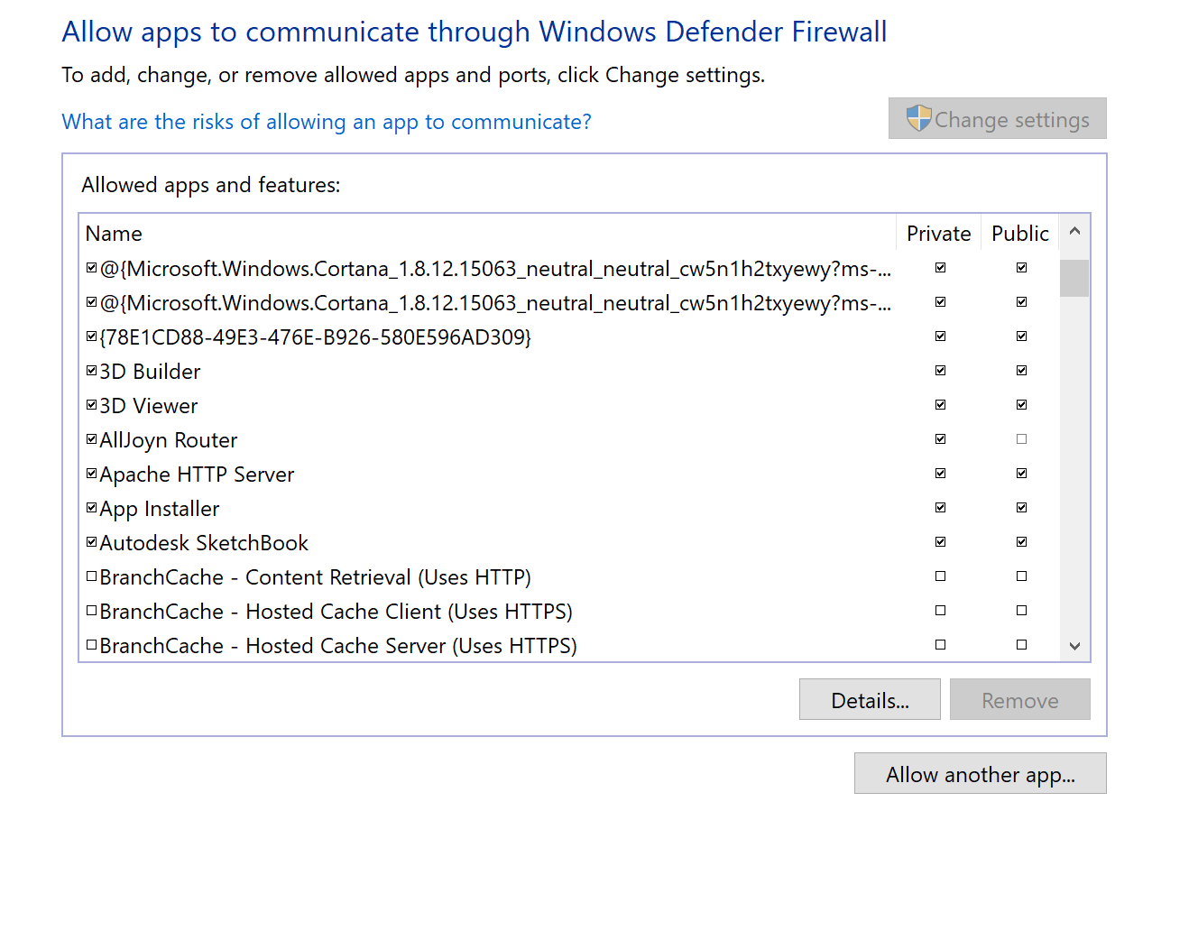

STEP 13: Configure the web server for your own domain -- Add the Following folders in the “wwwroot folder” and creating a html file in each folder with the codes.

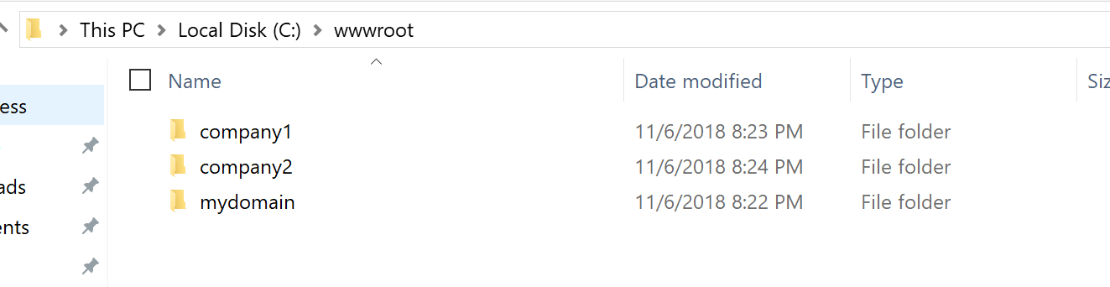

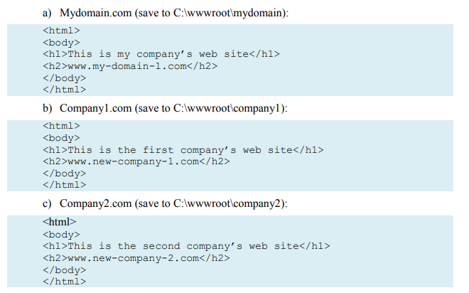

STEP 14: Now change the directory root in “*httpd.conf”* file to access the mydomain folder.

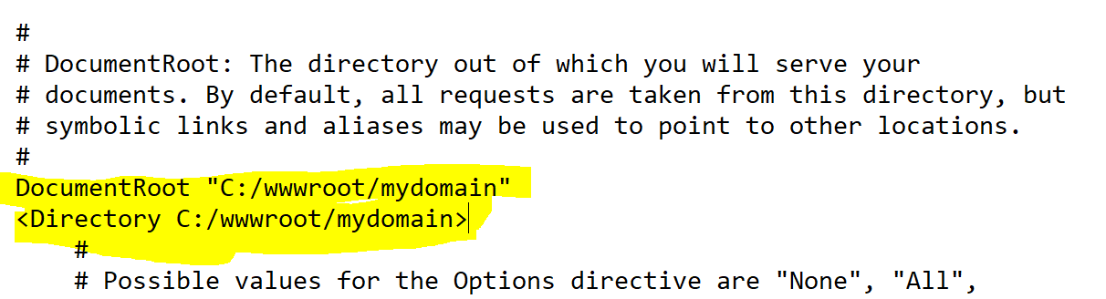

STEP 15: Configure the additional domains adding the code in “*httpd.conf*” file and restart the Apache webserver.

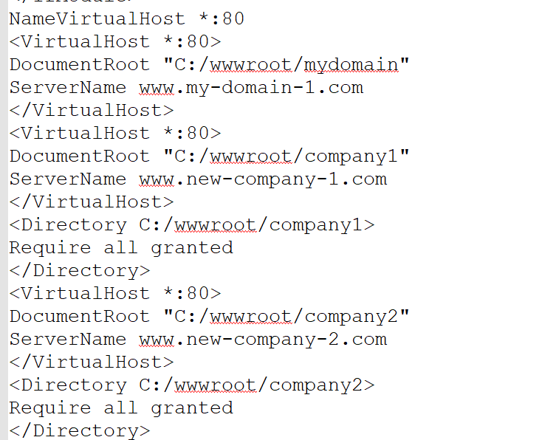

STEP 16: Testing the Server locally--Go to Internet Explorer and got to settings and go to Internet options and go to general and click on Every time I visit the webpage and click on ok and click on ok.

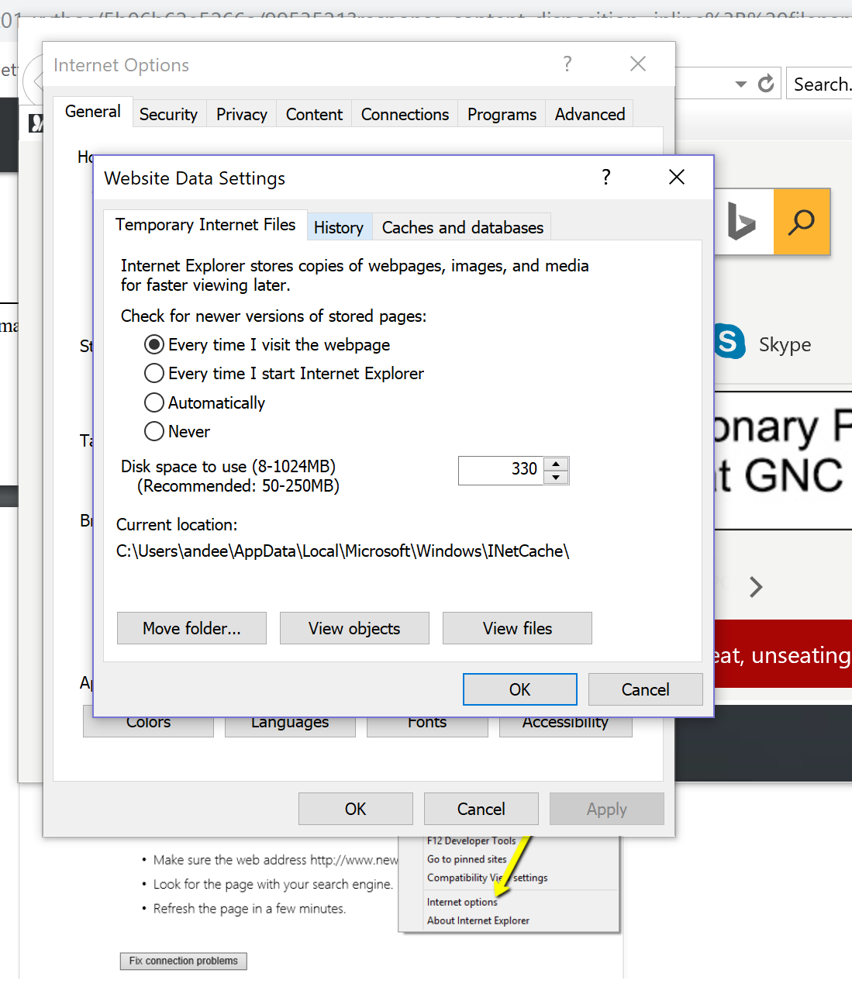

STEP 17: Go to Security in Internet options and select Trusted sites there we will add the websites links— http://www.my-domain-1.com , http://www.new-company-1.com , <http://www.new-company-2.com>. And click on close and click on close.

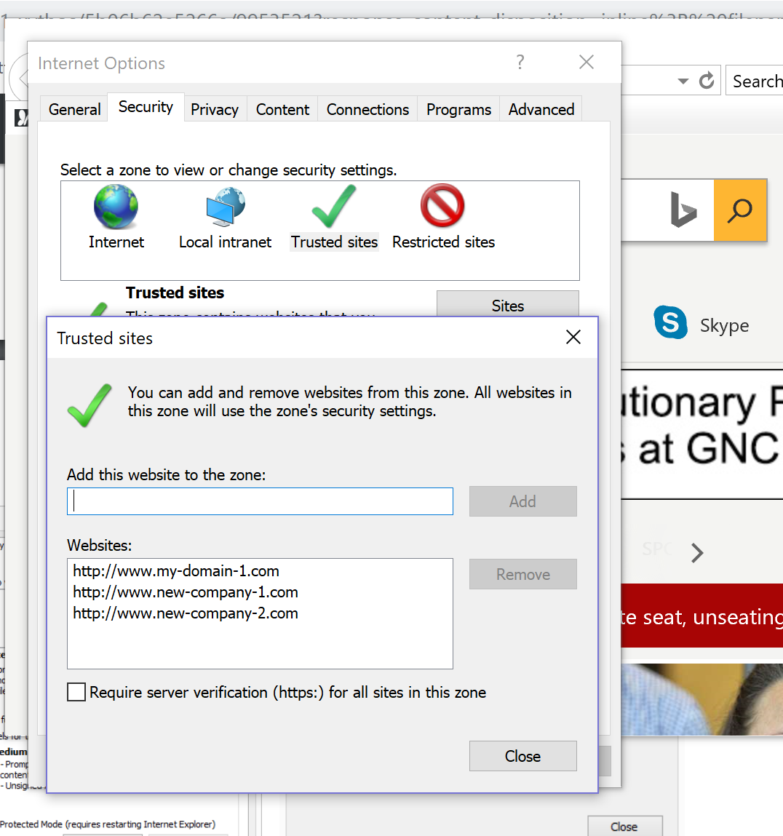

STEP 18: In order to access the DNS Server we have to know the IPv4 address and add them to the hosts txt file.

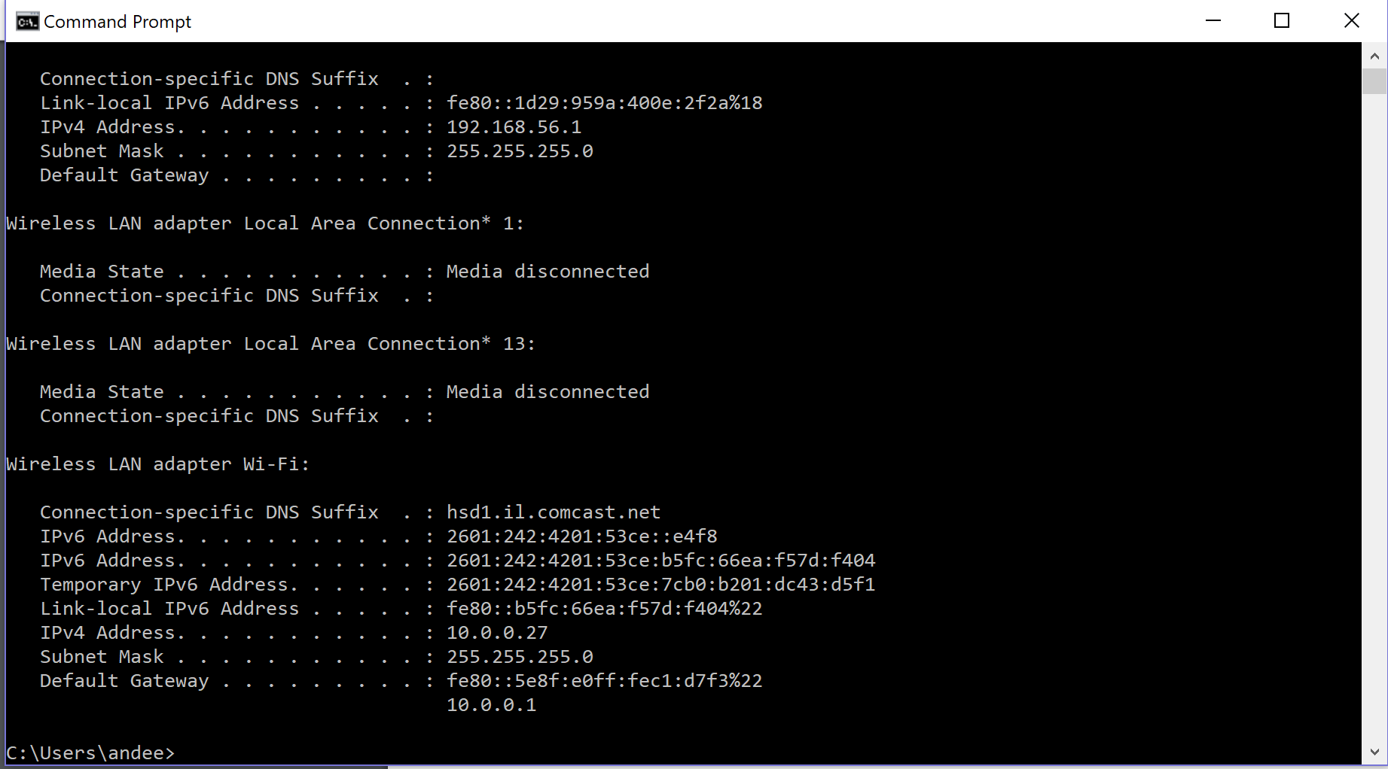

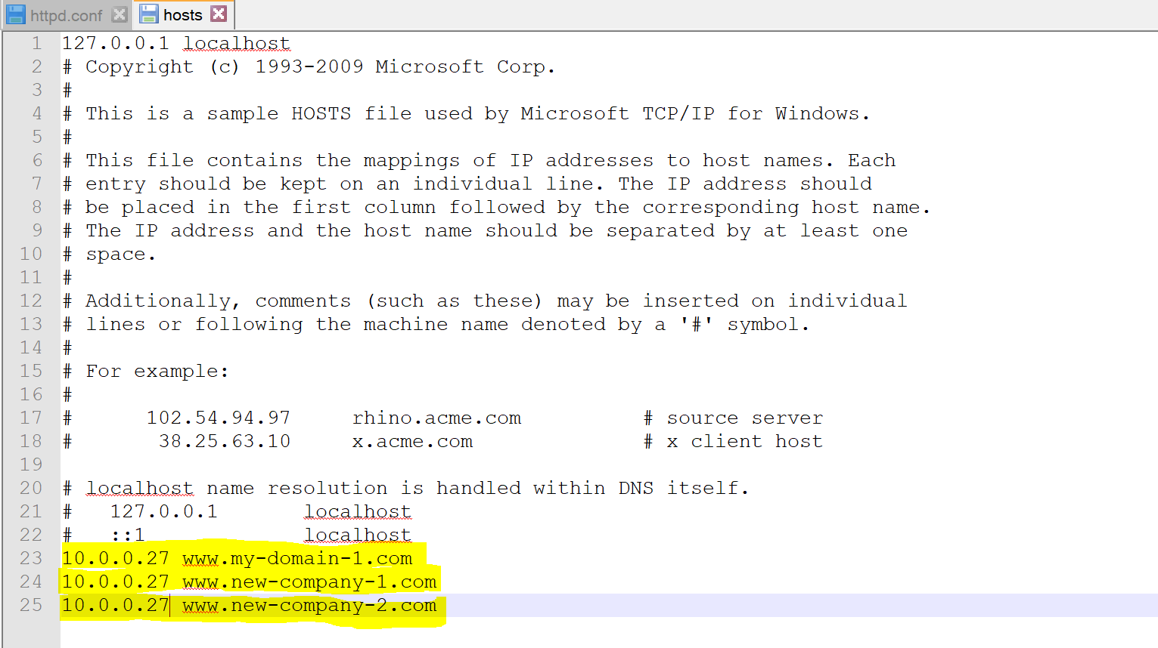

And check the Websites

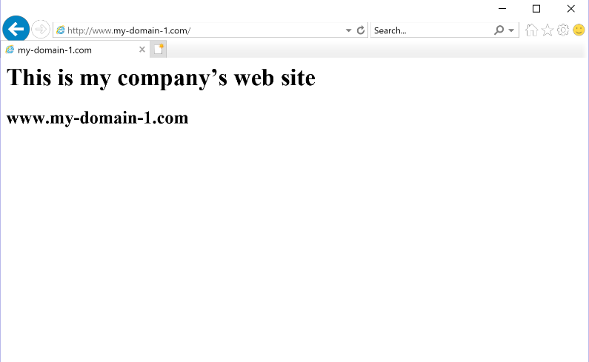

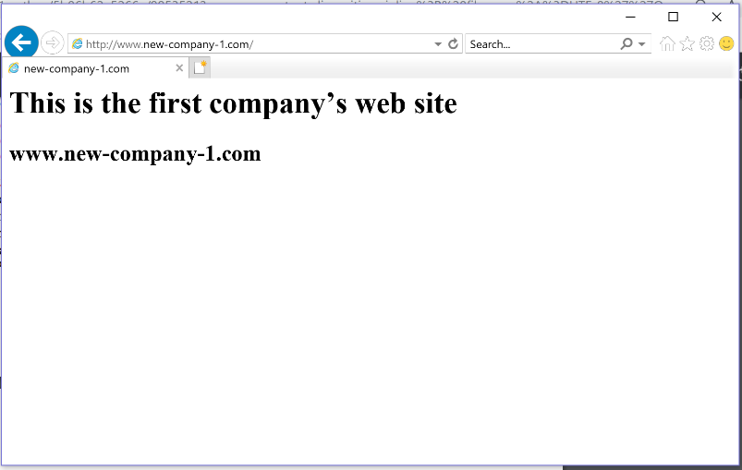

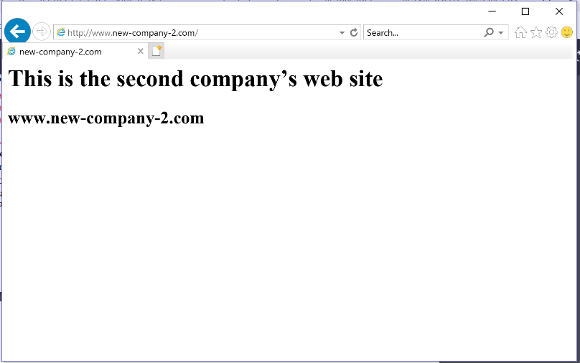

STEP 19: Now Testing the server remotely and checking in other’s system

For this we need to configure the IP address like in the STEP 18 in client’s system and adding the domain links in the hosts file.

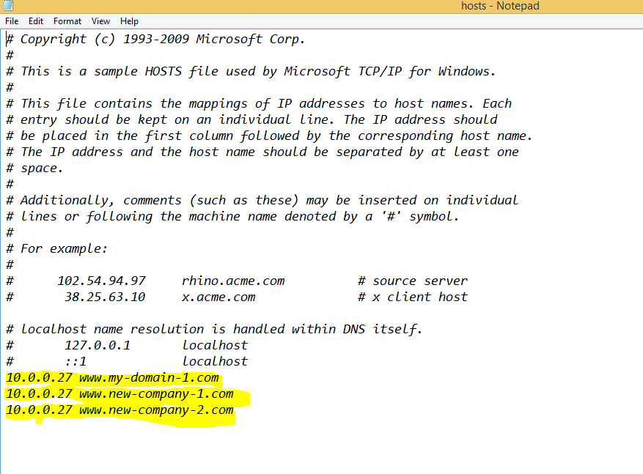

And checking in client’s web browser

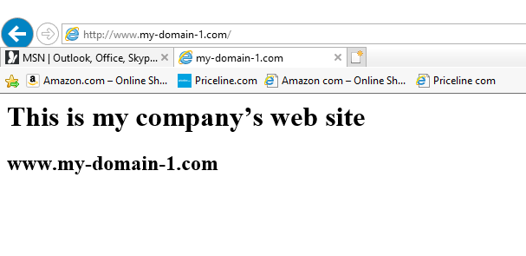

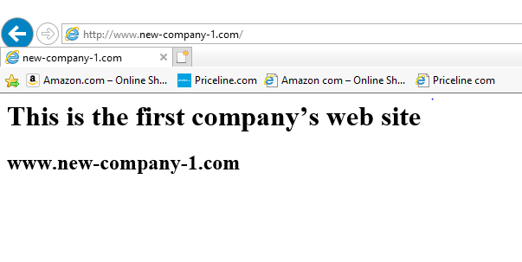

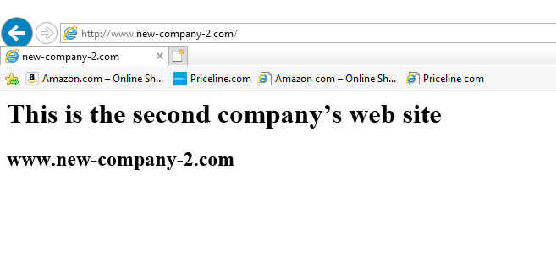

1) Discuss some of the precautions you should take before taking your web site “live” on the Internet. There is a web site called “Shields Up” that can help you answer this question. You can access it here: http://grc.com/default.htm.Find the Shields Up link on this page and follow it. Perform a port test on your server. Report your results.

Answer:

Precautions:

1) We have to review everything on our website and make sure everything is working properly like photos and videos etc.

2) Checking the responsiveness of the web server and suitable for all web browsers and across all the types of devices.

3) Checking every detail and feature is clear and boosting the site speed so that it loads as quickly as possible.

4) As soon as the website is launched we have to check the website from different aspects and these are know as analytics to evaluate our website and check what is working and what doesn’t.

5) Ensure there is no data loss before launching the website by setting site security and backing up the data regularly and keeping the copies of the website and launching the copies in case of any wrong happens.

Port Test on my Server:

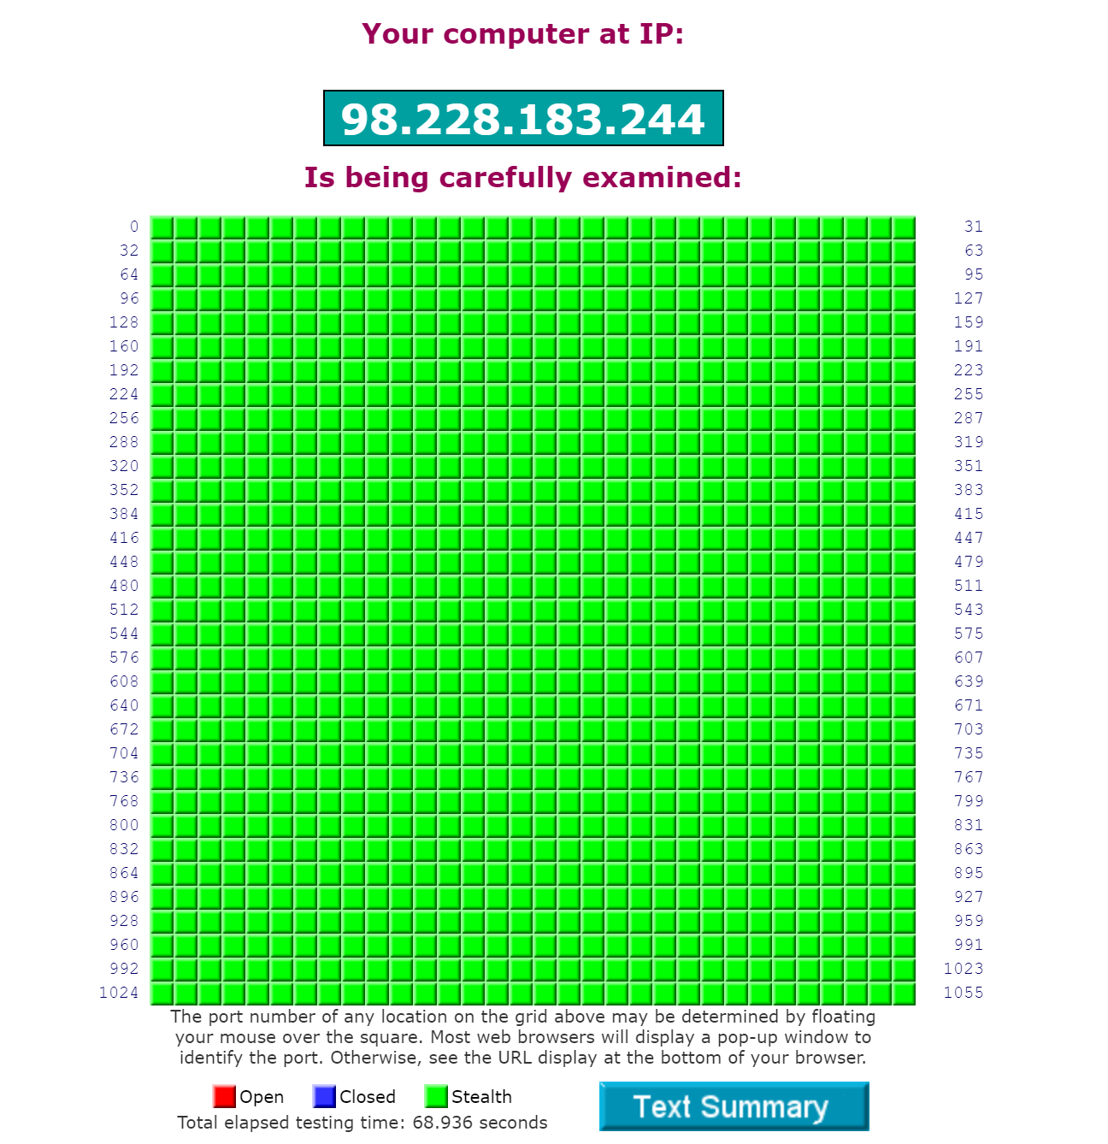

2) This lab focused on name-based virtual hosts, but mention was made of IP-based virtual hosts. Discuss IP-based virtual hosts and how they differ from name-based virtual hosts. Is it possible to host more than one web site using different IP addresses if your server has only one network interface card (NIC)?

Answer:

|  |  |
| --- | --- |
| IP based virtual hosts | Name Based virtual hosts |
| -> It will not share with anyone else.  ->Run more than one web site on same server machine.  ->In IP based virtual host you must have greater than one IP address allotted to the server.  -> A separate IP for each domain on a single server is used in IP based | -> Virtual hosts share the same name.  ->Host multiple websites on same IP address.  -> In name based virtual host, you must have a directory where all your website files will be stored.  ->Number of domains on a single machine is used in name based with one IP. |

3) What does URL stand for? Compare and contrast the following: URI, URL and URN.

Answer:

URL – Uniform Resource locator

|  |  |  |
| --- | --- | --- |
| URL | URI | URN |
| ->URL—Uniform Resource locator.  ->URL is subset of URI.  ->URL Includes protocols like http , ftp etc., domain , path and path.  ->URL is a locator.  ->Effective to use. | ->URI—Uniform Resource Identifier.  ->URI is superset of URL and URN.  ->URI Includes Text format.  ->URI is used identify a resource by a location , a name or both.  ->Some times effective and some times not. | -> Uniform Resource Name.  ->URN is subset of URI.  ->URN includes unambiguous way to identify a resource such as ISBN Number.  ->URN is a name.  ->Ineffective to use. |

**CONCLUTION:**

Web server is created with the help of apache web server software, a number of webpages are hosted for a set of domains like internet service provider. Configuration of web server so that it reacts to the set of requests for the company has made. Changes to the DNS server has also been made, overall there has been a great exposure to the web server configuration